
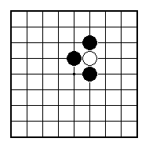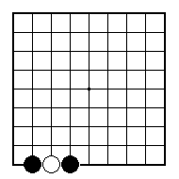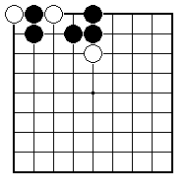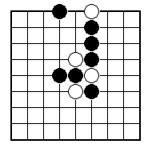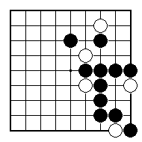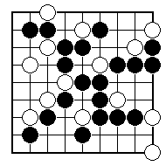
Black to play and take off a white stone.

Black to play and take off a white stone.

Black to play and take off a white stone.

Black to play and take off a white stone.

Black to play and take off a white stone.

Black to play and take off a white stone.

NAME:
BRITISH GO ASSOCIATION CERTIFICATE LEVEL 1 - SHEET 1

CAPTURING STONES

